Azure Administrator AZ-104
Lab Guide

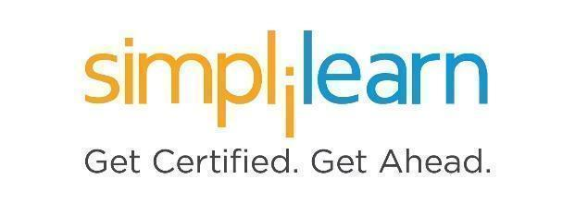

This section will guide you to:
- Use labs to execute all demos included in this course

This lab has two subsections, namely:
    - Starting practice labs on LMS
    - Checking the subscription assigned for your Microsoft Certified Associate: Azure Administrator AZ-104 to perform all the demos
    - Best practices to use the lab

Step 1: Starting practice labs on LMS
- Login to Simplilearn LMS
- Go to the respective course
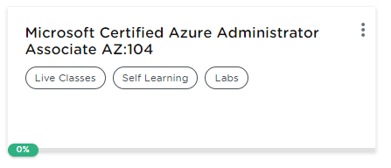
- On the left, you will find multiple tabs to access multiple components of the course
- At third from the top, you will find the PRACTICE LABS tab
- Click on it
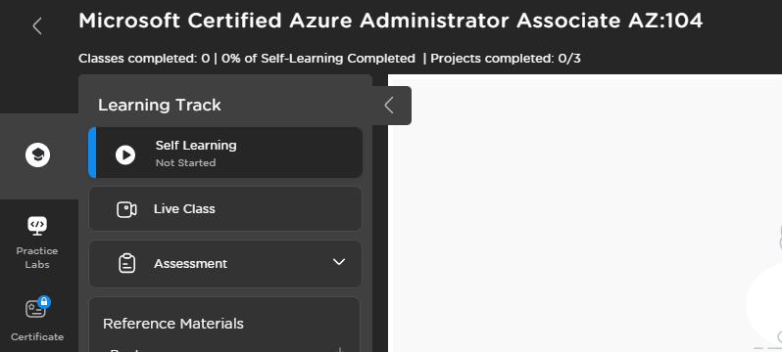

- As a new window opens, first click on Azure Lab (AZ 104 Course) and then click on Launch Lab

- This will launch practice labs for this course

- Once the lab instance is started, you will get the credentials to access the lab.
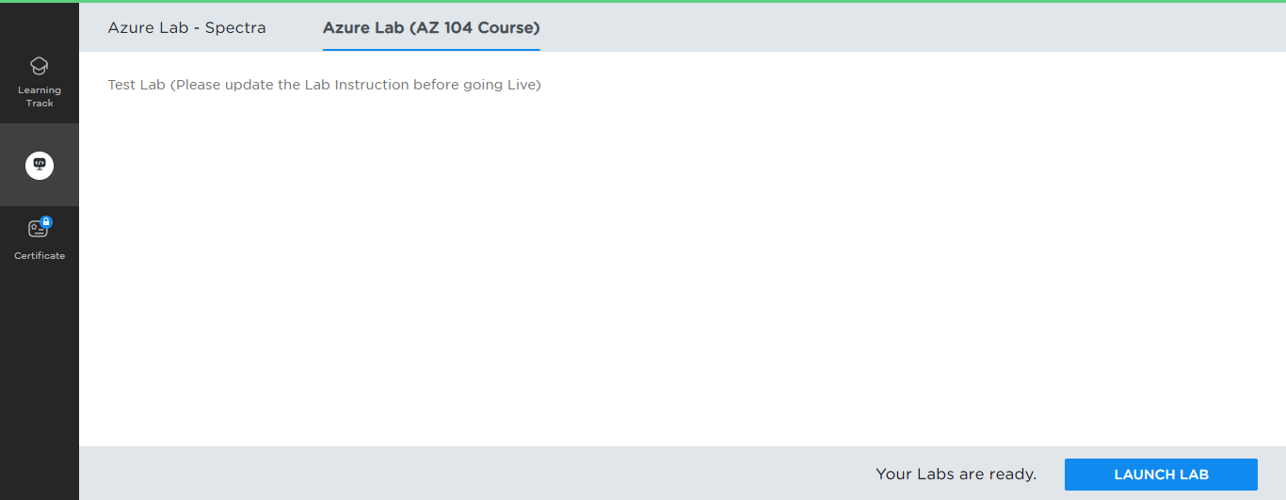

- You can login to the Microsoft Azure Portal with those credentials.
- After the credentials are validated, you will be directed to the Azure Portal.
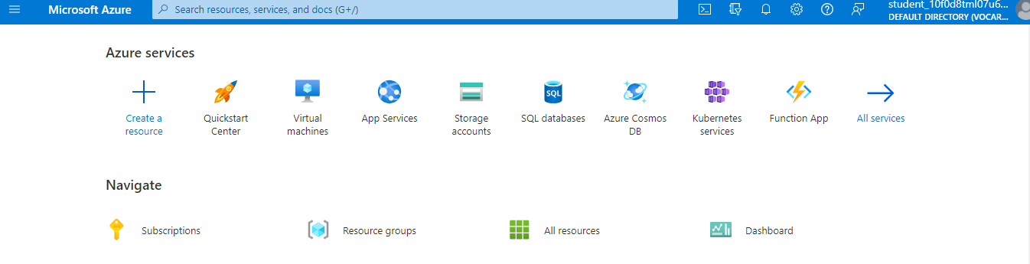

Step 2: Checking the subscription assigned for your Microsoft Certified Associate: Azure Administrator AZ-104 to perform all the demos

- Search using the keyword subscription in the search bar present at the top and select it
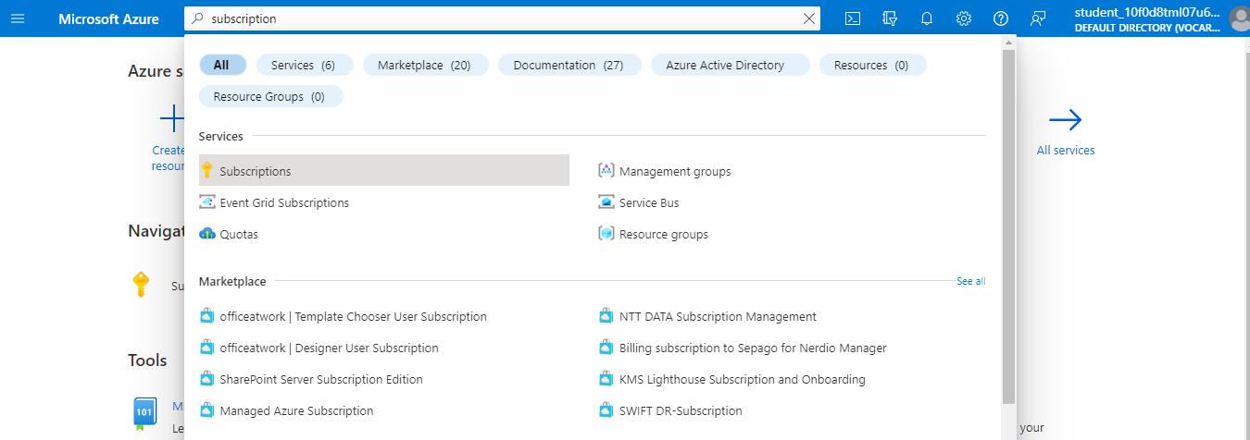

- You will be able to see an active subscription or your lab to practice all the demos

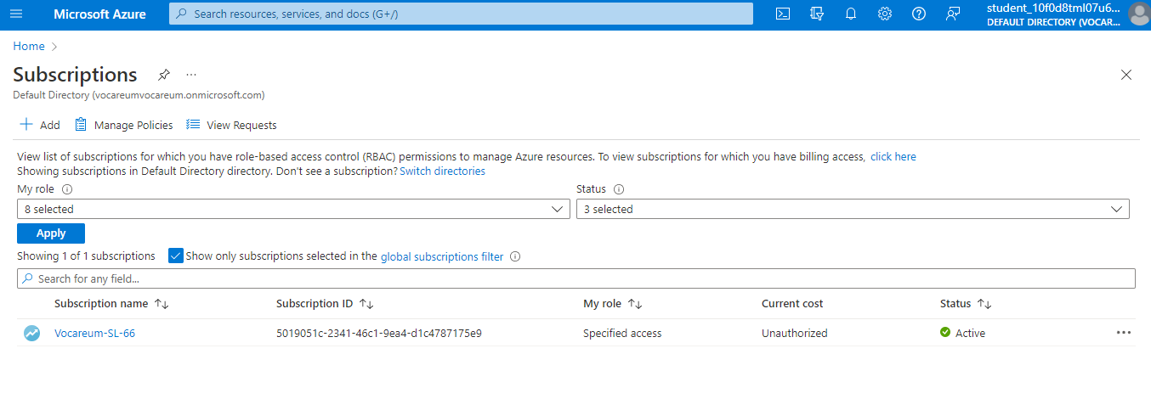

Step 3: Best practices to use the lab

As we are using this Azure lab for our learning purpose, we can follow the below best practices, avoiding access usage of the credits assigned to you.

Billing Alerts:
You can configure spending alerts to make you aware of when your usage is hitting your limit for the month. Using the cost analysis features supplied by Microsoft means you will be alerted when your Azure spend hits the configured limit.

Housekeeping:
Deleting unwanted resources, once you have finished with resources, delete them, and you are no longer charged. One of the main benefits of using cloud resources is the flexibility and transient nature of the services. As soon as you no longer need something, delete it, and you stop paying for the services.

Implementing the usage of Resource Groups correctly for logical grouping of resources also means you can remove whole groups of unused resources in one step by deleting the owning resource group.

Automation:
Virtual Machines you only pay for while they are running, so if you are happy to pay for the storage of the virtual disks, switching the machines off after a training session reduces your costs.

The powering down of virtual machines can be automated and is now also an option during VM creation. This ensures that virtual machines are switched off even if you forget to trigger the shutdown of the virtual machine manually.

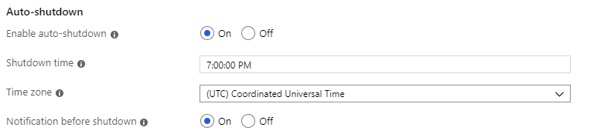

The option is not applied by default if you are using PowerShell to create your VMs but by adding in a few additional lines; you can configure the auto-shutdown.

